A

10/6/2013

APPENDIX

12-Week Regional Sales Forecast

Orange Team 6:

*Team Lead:* Phillip **Domschke**

*Other Contributors:* Marc Zimmerman, Steve Neola, Wes Ledebuhr, Jacob Frost



1: Historic Sales Pattern by Region. Different colors identify different years. .

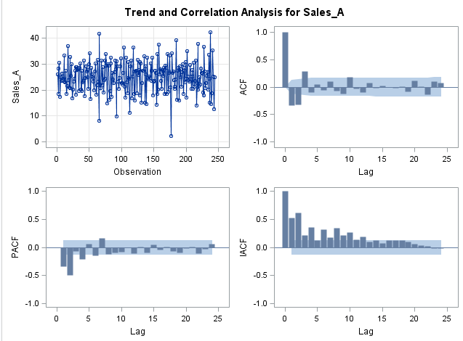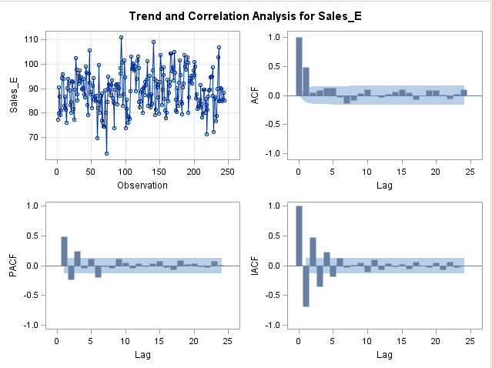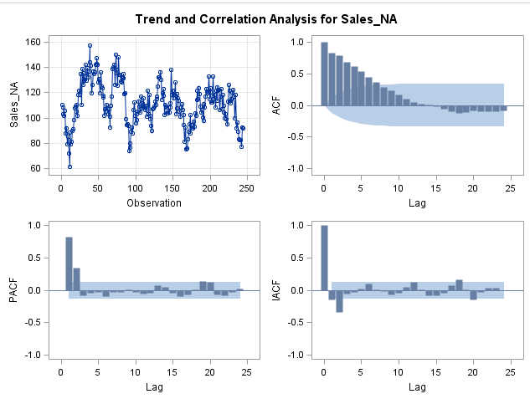

4: Trend and Correlation Analysis for Sales in Asia

2: Trend and Correlation Analysis for Sales in North America

3: Trend and Correlation Analysis for Sales in Europe

5: Residual Normality Diagnostics for Sales in North America

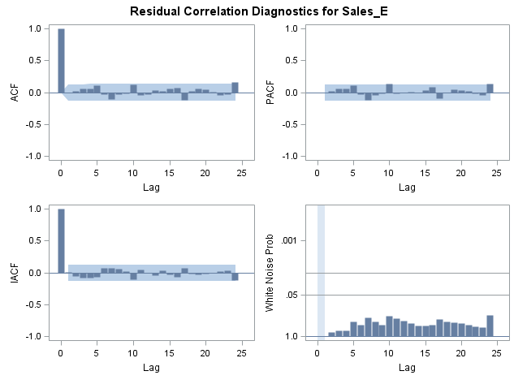

6: Residual Correlation Diagnostics for Sales in Europe



7: Trend and Correlation Analysis for Sales in Europe

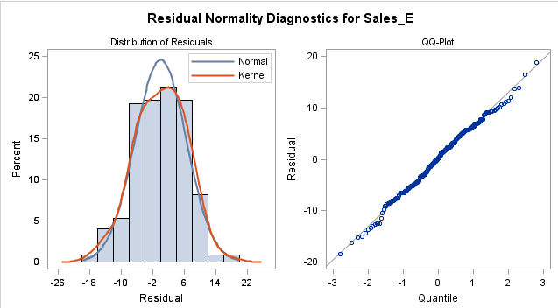

8: Residual Normality Diagnostics for Sales in Europe

 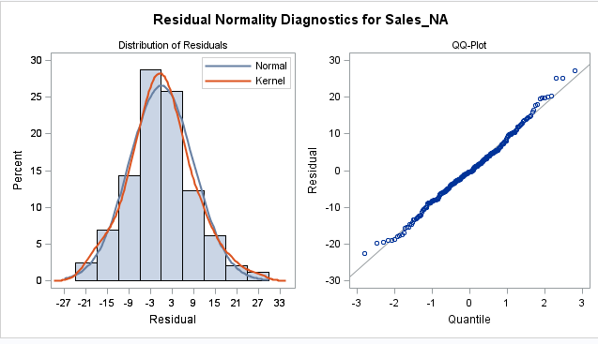 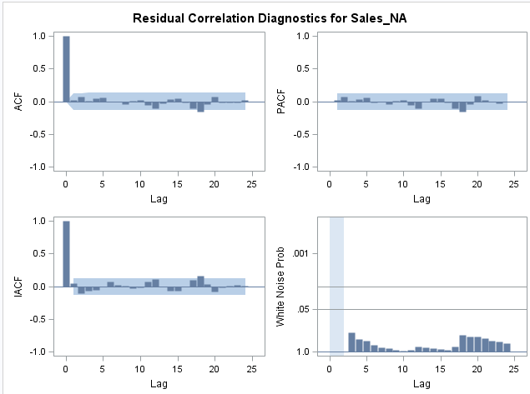 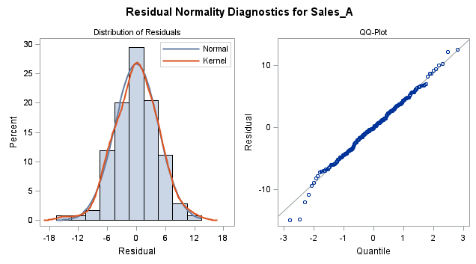 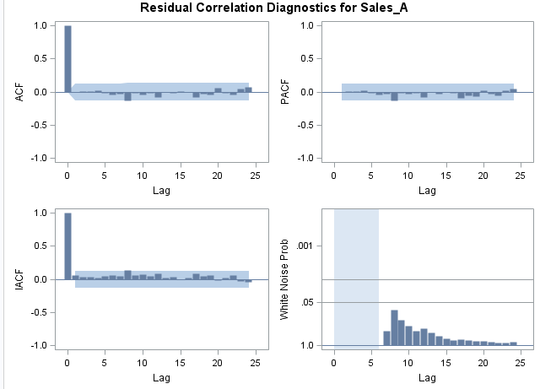

9Trend and Correlation Analysis for Sales in North America

10: Residual Normality Diagnostics for Sales in North America

11: Residual Correlation Diagnostics for Sales in North America

12: Trend and Correlation Analysis for Sales in Asia

13: Residual Correlation Diagnostics for Sales in Asia

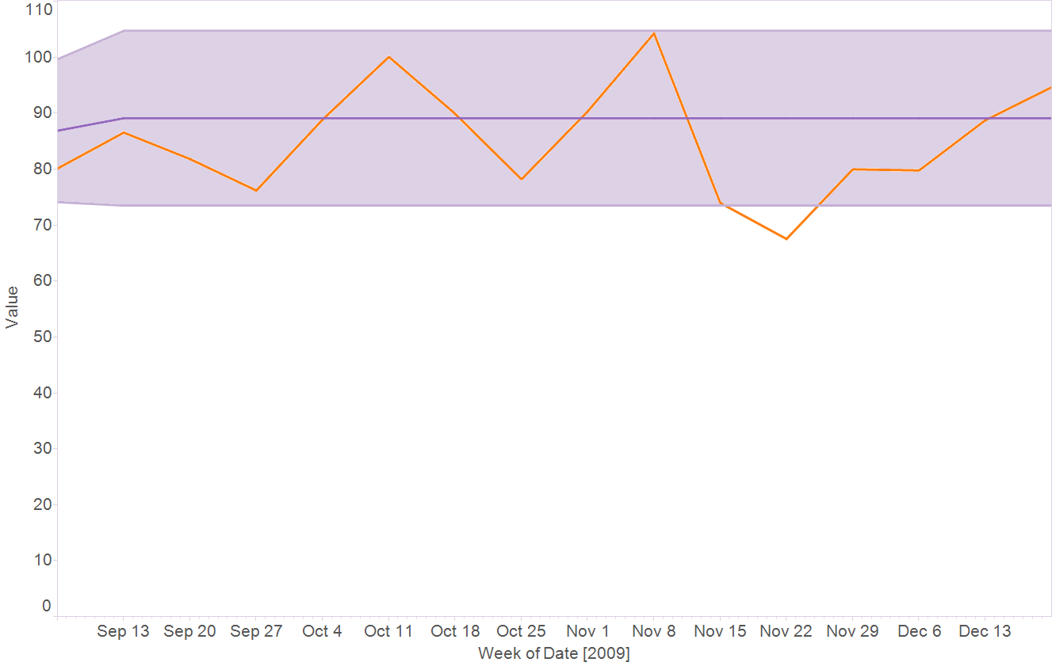

14: Historic Sales in Europe (orange) and the Forecast with its 95% Confidence Interval (purple)

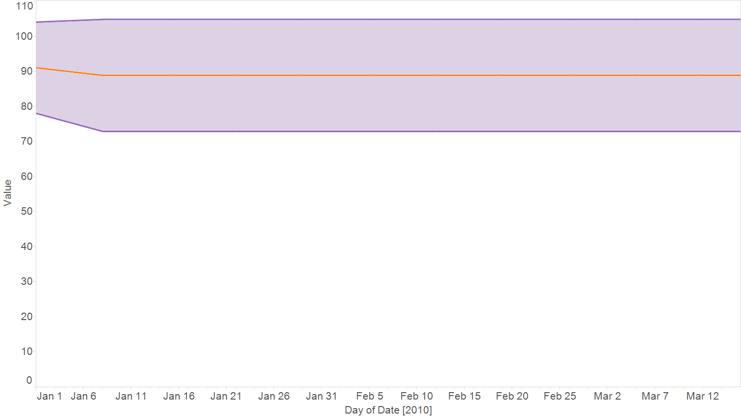

15: 12-week Forecast for Sales in Europe

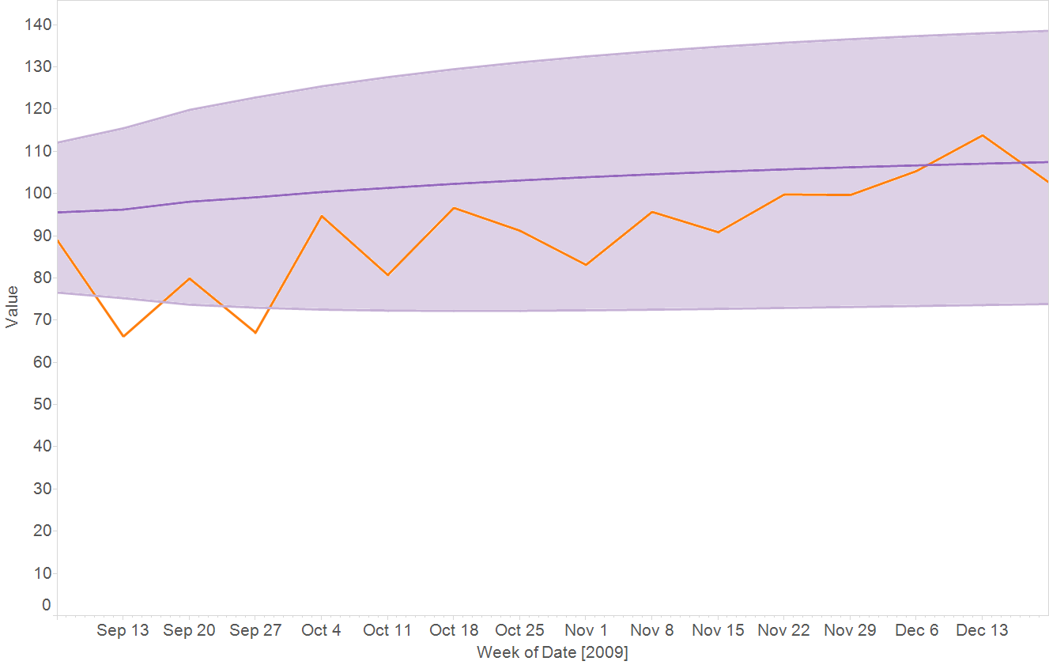

16: Historic Sales in North America (orange) and the Forecast with its 95% Confidence Interval (purple)

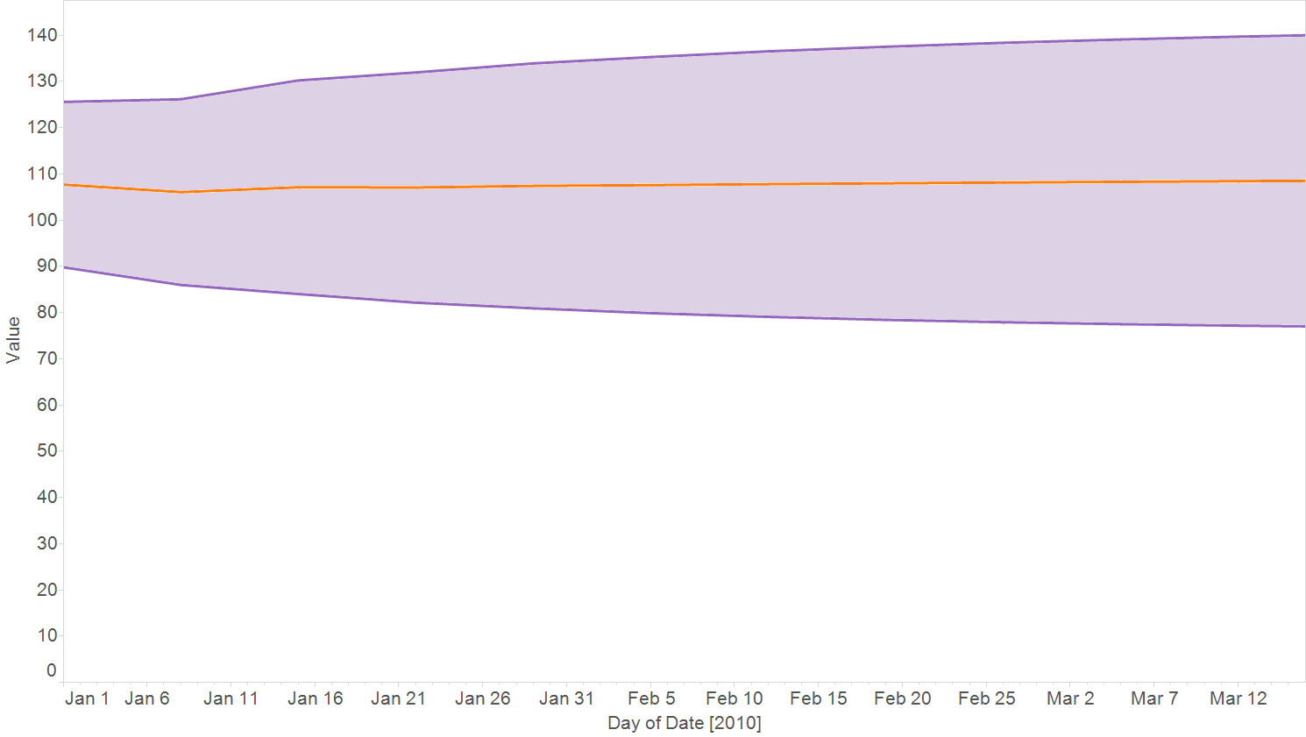

17: 12-week Forecast for Sales in North America

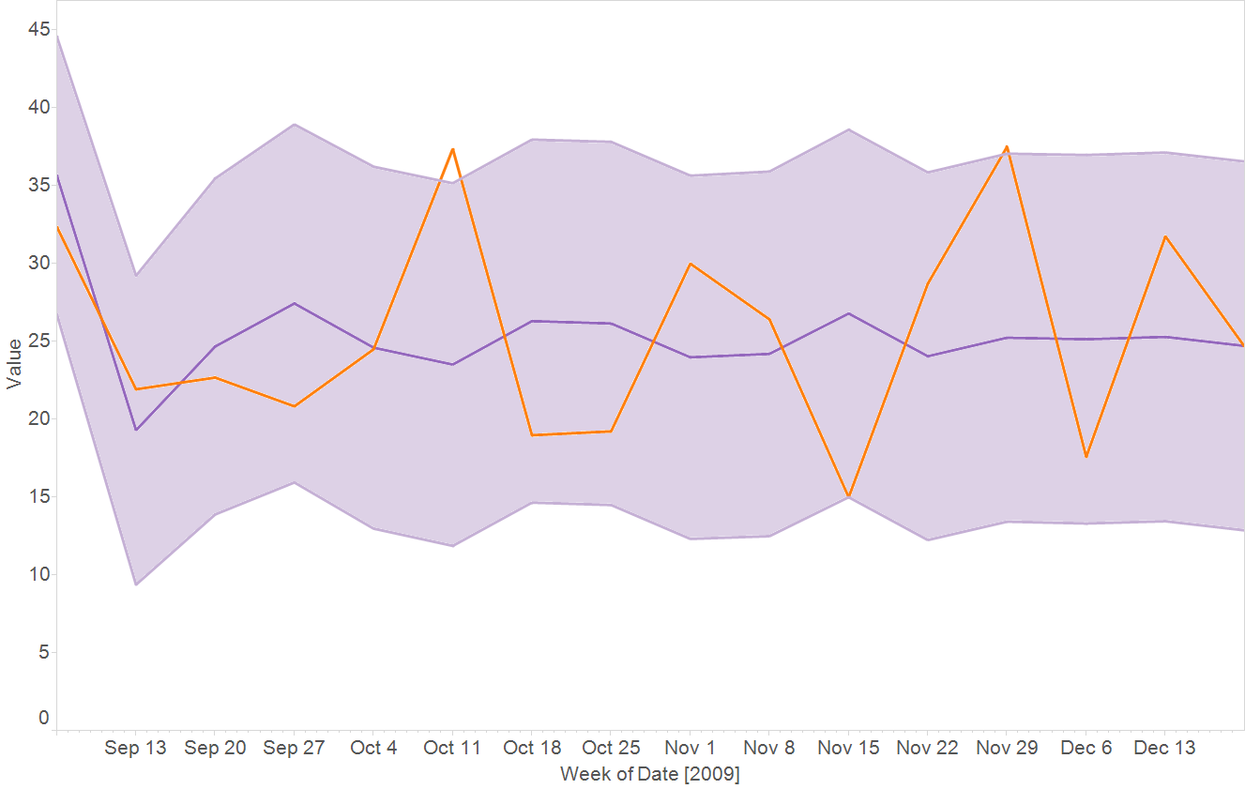

18: Historic Sales in Asia (orange) and the Forecast with its 95% Confidence Interval (purple)

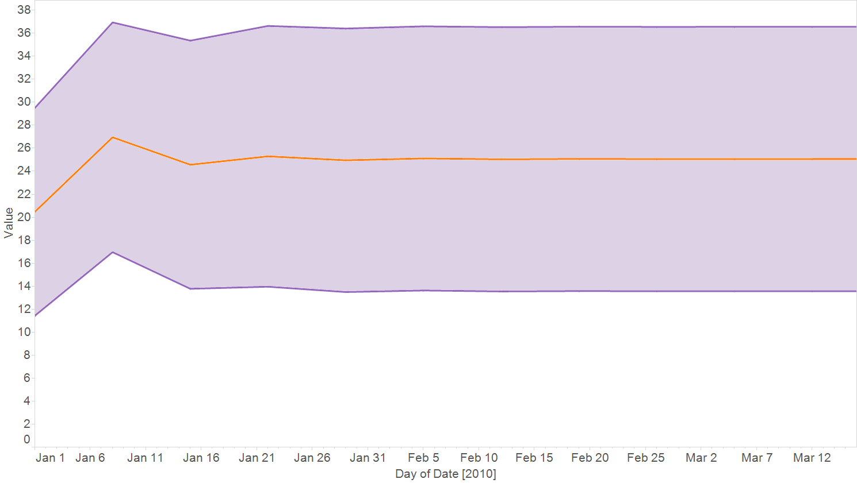

19: 12-week Forecast for Sales in Asia